**[Consultant – A Strange Knee Injury](https://doctorbillgould.com/consultant-a-strange-knee-injury/" \o "Permanent Link: Consultant – A Strange Knee Injury)**



Double Take An Intriguing Diagnosis

A Case of Trauma in a Man With a Congenital Leg Deformity

William S. Gould, MD

Woodinville, Wash

A 29-year-old man complaining of pain in his left thigh and knee presented 2 hours after being struck by a 200-lb spool of wire that was rolling down a hill. His father, an electrician, keeps spools of heavy cable in the front yard. The patient’s 15-year-old brother, along with another “maturity-challenged” young man, chose to play with the reels, rolling them at each other. One of the spools escaped their control and rolled down the hill, heading toward both the patient and the neighbor’s brand-new sport utility vehicle. The patient saw the rolling spool and threw himself between it and the car. The laws of physics prevailed, however, and the spool rolled over the patient’s left leg, continuing on to strike the vehicle and essentially destroying it.

**Medical history**.The patient was born with a right clubfoot, which had been corrected surgically at birth. He had a mild congenital leg-length discrepancy (the right lower extremity was slightly shorter than the left). He denied other contributory orthopedic problems.

**Physical examination.** The patient was alert and oriented but walked with an antalgic gait because of pain in his left leg. The left distal medial thigh demonstrated marked swelling with superficial abrasions. There was a divot over the anterior surface of the left knee, the patella was not palpable. There was no genu valgum or genu recurvatum. The knee was tender over the medial surface, but not over the joint line.

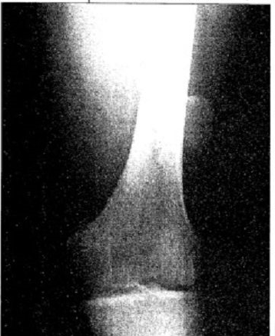

A hard, nontender, immovable, 5-cm mass was palpated over the anterior surface of the distal thigh. The tibial tubercle was not tender. The knee was totally stable, with near full range of motion and good strength on resisted extension. Results of McMurray’s test were negative, and the neurovascular examination was unremarkable.

**Assessing the need for surgery**. After viewing the x-ray films (Figure), I called the orthopedic surgeon and alerted him to schedule immediate surgery for the patient for a total rupture of the patellar tendon.

Back in the exam room, I told him there was good news and bad news. He wanted the bad first. “Okay, you need immediate surgery to reattach your kneecap.”

“Hold on,” he responded. I don’t have a kneecap. I was born without one. A hundred doctors have told me that since I was a kid.”

My patient then asked what the good news could have been. I told him that the surgeon I had consulted was a world-renowned knee specialist. I rushed from the room to call the surgeon’s home to cancel the procedure.

**Discussion**. This is probably a case of congenital patellar dislocation associated with severe patella alta. I have discussed this with several experienced, prominent orthopedists and radiologists, but only one practitioner had ever seen this before. That one case was in a young woman with juvenile rheumatoid arthritis.

In the literature, references to chronic caudal positioning of the patella generally refer to the common finding of patella alta, in which the patella is only a centimeter or so proximal…missing text…

While this patient returned to my office after having iced the injured knee for a week and had only minimal ecchymosis over the medial surface of the knee. He was walking without an antalgic gait.

The patient’s brother, however, was less fortunate. The 15-year-old and his pal are working summer jobs to pay for the neighbor’s ruined auto. The patient reports that by the third week of June, his brother was saying he couldn’t wait for school to start.

The patient’s injury might have been easier to heal than the rift in my relationship with the orthopedic surgeon, had it not been for the latter’s professional interest in this unique case. Since the surgeon had never before seen a patient with this condition, he was extremely interested in reviewing the x-ray films and discussing the findings with me. Fortunately, he still takes my calls.